# **Designing a Data as a service and Model as a service**

## Big Data and Intelligent Analytics - Fall 2022

## Assignment 2

## TEAM 5

## 

| **NAME** | **NUID** |
| --- | --- |
| SAI VENKATA SAMANTH KODURU | 2983840 |
| SHANTAN DADI | 2927718 |

# **Data as a Service**

API using Fast API that can retrieve samples of different kinds

The 5 functions that we have developed are

1. Drops rows with null/Nan cells
2. Returns an event on respect with the given ID
3. Returns events on the basis on the event type
4. Returns an the location with respect to the event_id
5. Returns all the events of a particular image type or a particular sensor reading

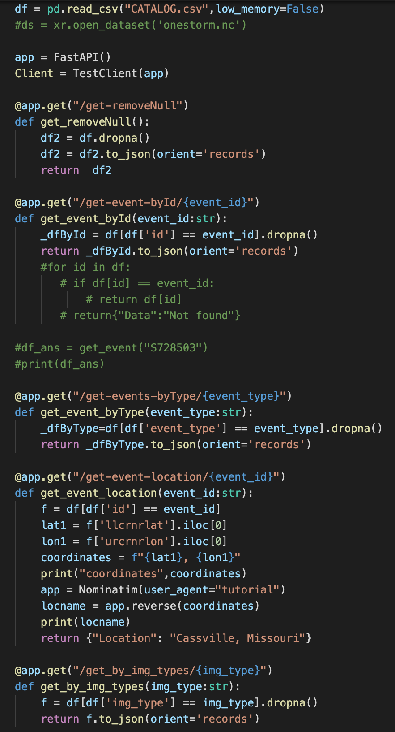

# **Testing Daas**

**DATA AS A SERVICE(DaaS.py)** [**http://127.0.0.1:8000/docs**](http://127.0.0.1:8000/docs) **:- Unit Test Document:**  
  
**API’s under DaaS:-**

**/get-removeNull/ :**  
This API drops rows with null/Nan cells and returns the JSON format of CATALOG.csv .

**/get-event-byId/{event_id} :**

This API returns an event on respect with the given ID.  
Description :  
event_id : String.

Example :- S835047

**/get-events-byType/{event_Type}:**

This API returns events on the basis on the event type.  
Description :  
event_id : String.

Example :- Tornado, Flood, etc.

**/get-event-location/{event_id}:**

This API returns an the location with respect to the event_id

Description :  
event_id : String.

Example :- S835047

**/get_by_img_types/{img_types}:**

This API returns all the events of a particular image type or a particular sensor reading.

Description :  
event_id : String.

Example :- vis, vil, etc.

## 

# References

* <https://www1.ncdc.noaa.gov/pub/data/swdi/stormevents/csvfiles/Storm-Data-Export-Format.pdf>
* <https://nbviewer.jupyter.org/github/MIT-AI-Accelerator/eie-sevir/blob/master/examples/SEVIR_Tutorial.ipynb>
* <https://www.ncdc.noaa.gov/stormevents/ftp.jsp>
* <https://github.com/MIT-AI-Accelerator/sevir_challenges>
* <https://github.com/googlecodelabs/tools>